**CAVE MAN GAME**

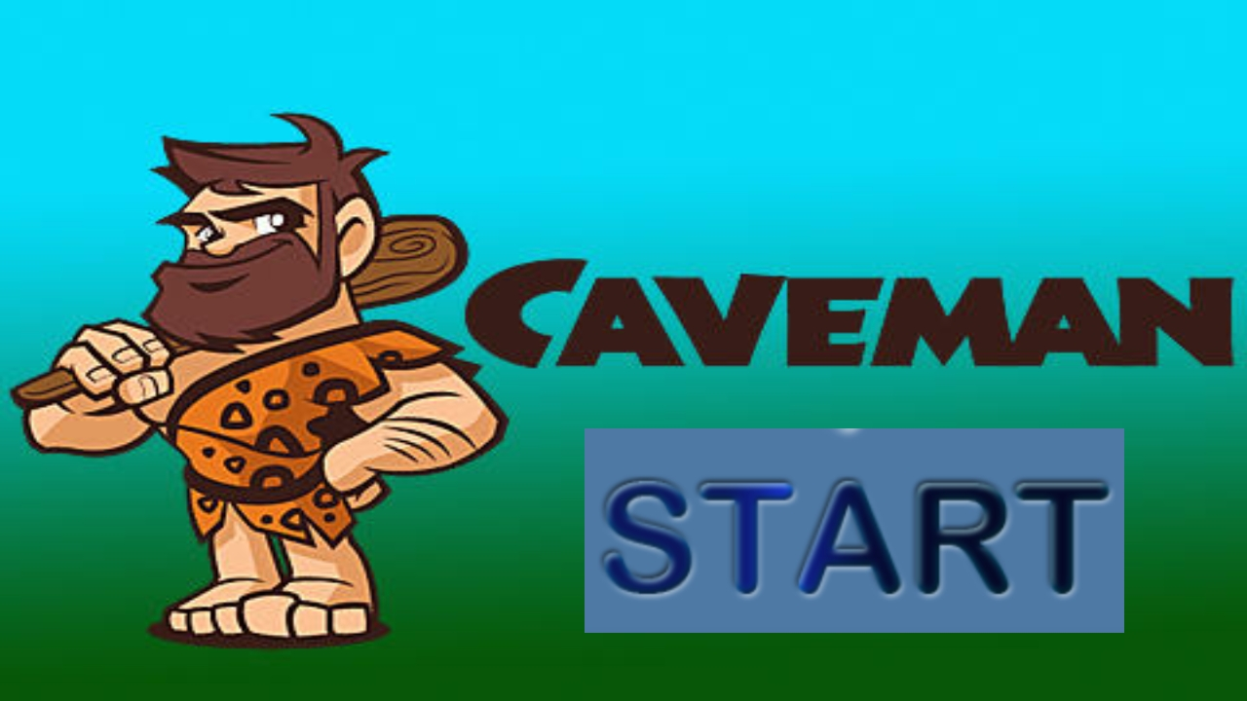

* **PROJECT TITLE :- CAVE MAN GAME**
* **GROUP ID : D**
* **TEAM MEMBERS :**

**1.) AKASH RAMANAND RAJAK**

**435**

**2.) PALLI HRITAM RAO**

**482**

* **PROBLEM STATEMENT**

**Build an Android Based Application – Cave Man Game, which is Adventurous Game and store the score in Database(here SQLite).**

* **DETAILS OF APPLICATION**

**1.) The Game is developed on Android Studio Platform.**

**2.) For storing data (SCORE of Player), we used SQLite Database.**

**3.) To view the database table of score of Player, we used DB Browser (SQLite).**

** **

* **FUNCTIONALITIES &**

**FEATURES**



**1.) When we open the game, we get five button in the menu option, namely**

**  **

** **

**2.) To play the game, we click on  button and it will redirect us to the level selecting page. Then we can select any level of our choice and start the game.**

**3.) To view the score of Player with particular ID, we click on **

**button. The score of player of particular id is shown in scroll view.**

**4.) When we go to  button, we get chance rate the game out of 5 – stars.**

**When we click on  button, a toast message is shown on screen, regarding our rating.**

**5.) When we click on  button, we get some helpful Q/A which will help us or guide to understand the game. All the Q/A are displayed on the screen using scroll view.**

**6.) When  button is pressed, the developer of this game app will be shown.**

**  **

**7.) Also, on each page that we select, we get the option on the top-right corner to play a recommended music while playing.**

**8.) When a particular level finishes, a message of  , to go to level select window, we can click any where on the screen where the GAME OVER message is shown or if we want to go to the menu option window, press the back key.**

* **PLAY AREA EXPLAINATION**

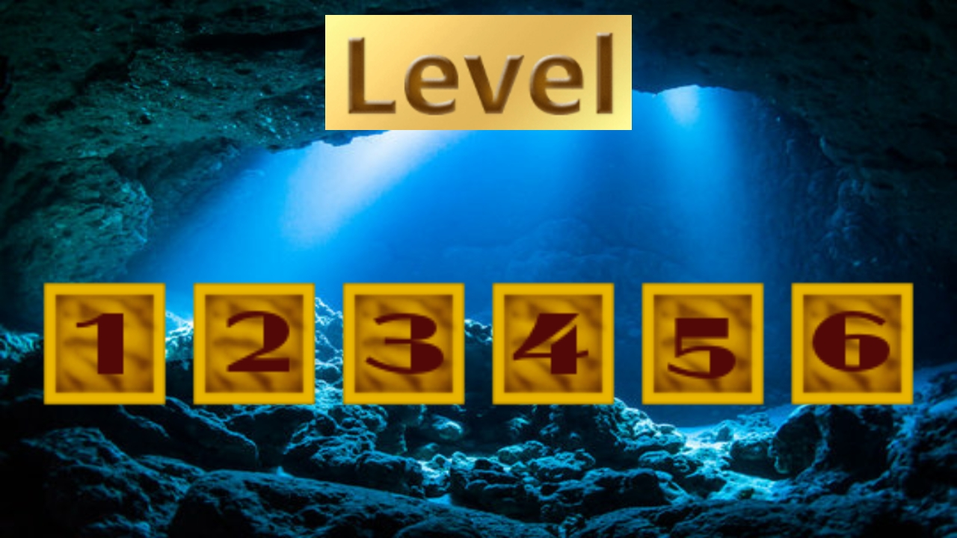

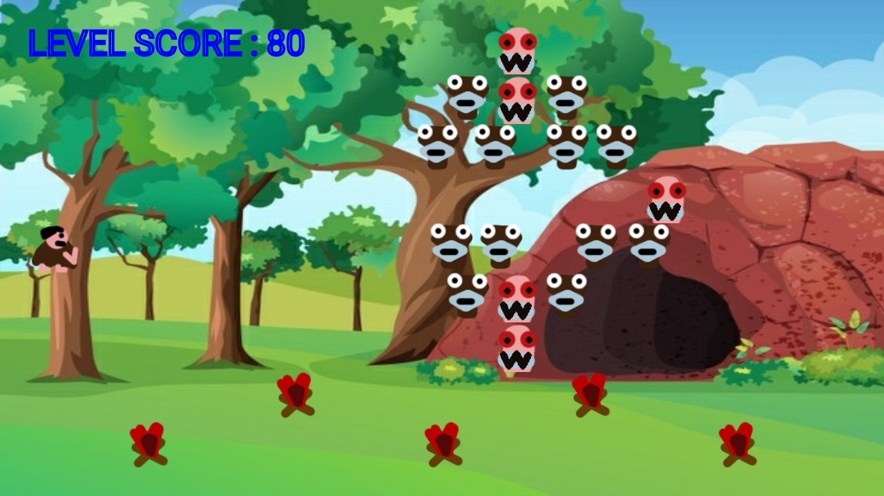

**1.) When we select any level out of 6 levels, we are redirected to the Game Play Area.**

**2.) Here in Play Area, we see a caveman sitting on the tree, enemies coming from right – Simple enemy (in red color) and jumping enemy (in black color).**

**3.) We will be able to kill the Simple enemy and not the jumping enemy.**

**3.) To Play the particular level, we need to put the cursor on the top of caveman(i.e. man sitting on the tree), and draw a free-handed line towards the bunch of enemies coming from right side.**

**4.) When we stop the line draw, the axe will move in that drawn free-handed line.**

**5.) When the axe touches any simple enemy, that enemy get killed and out Level Score increases by 10 points for each simple enemy killed.**

**6.) And when axe touches the black enemy, it just pass through without killing it.**

* **CONCLUSION & COMMENT**

***Not with too much of graphics, but a simple game (also known as a flash) can be played for having fun.***

***The game has levels which could be interesting to unlock new things in it and we need to think before getting into the next rounds.***

***Game is all about having fun.***

**X—X—X—X—X—X—X—X—X**